Gel Documentation Form and Worksheet

HLA-B*58 (101.568-06/06u) Lot No: 6K7 Expiry Date: 2024-01-01

Name:__________________

Sample ID:______________

DNA Conc.(ng/ul):_________

Test Date:_______________

Tested By:_______________

Review Date:_______________

Reviewed By:_______________

***Interpretation:___________ Failed lanes: __________ Comments:_________________***

**Gel Picture**

|  |
| --- |
| PHOTO DOCUMENT |



Abbreviations

ICB: Internal Control Band

AmpS: Amplicon size

**Notes:**

Product sizes are approximate. For detailed information, see the lot-specific Specificity Table and Interpretation Table.

This table is intended as a guide. For interpretation always use the Interpretation Table and/or Specificity Table.

HLA-specific PCR products shorter than 125 base pairs have a lower intensity and are less sharp than longer PCR products.

Primer mixes 1, 9 and 17 may have tendencies of primer oligomer formation.

Primer mix 14 may have tendencies of unspecific amplifications.

Primer mixes 23 and 25 may give rise to a lower yield of HLA-specific PCR product than the other B*58 primer mixes.

Primer mix 32 contains a negative control, which will amplify a majority of HLA amplicons as well as the amplicons generated by the control primer pairs matching the human growth hormone gene. HLA-specific PCR product sizes range from 75 to 200 base pairs and the PCR product generated by the HGH positive control primer pair is 200 base pairs.



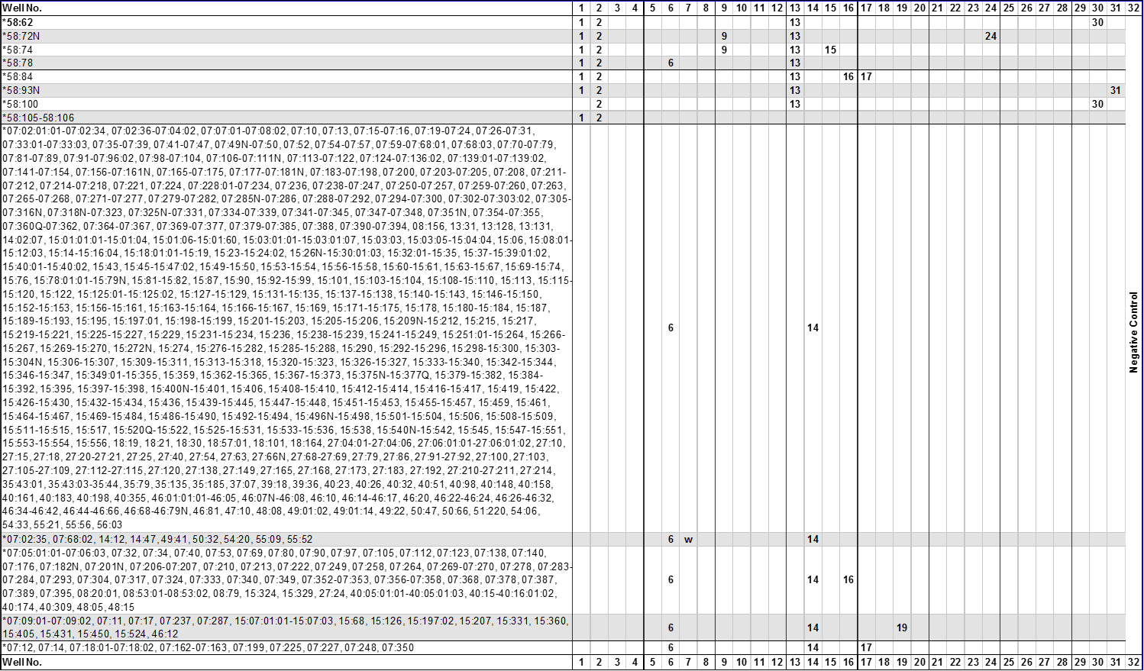

 





**1**HLA-B*58 alleles in bold lettering are listed as confirmed alleles on the on the IMGT/HLA web page [www.ebi.ac.uk/imgt/hla](http://www.ebi.ac.uk/imgt/hla), release 3.25.0, July 2016.

**2**Alleles that have been deleted from or renamed in the official WHO HLA Nomenclature up to and including the last IMGT/HLA database release can be retrieved from web page <http://hla.alleles.org/alleles/deleted.html>.

**3**The following HLA-B*58 primer mixes have two or more product sizes:

|  |  |  |  |
| --- | --- | --- | --- |
| Primer Mix | Size of spec. PCR product | **Amplified HLA-B*58 alleles** | **Other amplified HLA-B alleles** |
| **4** | 190 bp  230 bp | *58:04  *58:15 | *51:258 |
| **9** | 90 bp  160 bp  190 bp | *58:44  *58:08:01, 58:23  *58:72N, 58:74 | *07:219  *57:01:20, **A*02:01:33** |
| **10** | 115 bp  270 bp | *58:24  *58:09, 58:76 | **C*03:141, C*03:233, C*15:18**  *14:10, 18:22, 18:69, 18:105, 18:149-18:150, 35:21, 35:24:01-35:24:02, 35:81, 35:96, 35:109, 35:157, 35:188, 35:190, 35:233, 35:287, 37:04:01-37:04:02, 40:28, 44:190, 44:203:01-44:203:02, 44:275, 44:290, 51:04:01-51:04:02, 51:46, 51:56:01-51:56:03, 51:139, 51:227, 51:281, 52:88, 53:02, 53:06, 53:28, 57:14:01-57:14:02, **C*03:384, C*15:39, C*15:130, C*15:195** |
| **12** | 145 bp  235 bp | *58:13  *58:10N | *35:419, 49:06, 51:283 |
| **15** | 90 bp  155 bp  190 bp | *58:36  *58:12  *58:74 | *15:462, 57:01:01:01-57:01:22, 57:01:24-57:04:01, 57:04:03-57:15, 57:17-57:19, 57:21-57:35, 57:37-57:44, 57:46-57:50, 57:52-57:61, 57:63-57:68, 57:70-57:88, 57:90-57:108, 57:110-57:119, 57:121-57:127  *07:219, 57:58, 57:80, **A*02:42:01-02:42:02**, 02:310 |
| **16** | 100 bp  225 bp | *58:27-58:28:02, 58:65  *58:84 | *07:05:01:01-07:06:03, 07:32, 07:34, 07:40, 07:53, 07:69, 07:80, 07:90, 07:97, 07:105, 07:112, 07:123, 07:137-07:138, 07:140, 07:176, 07:182N, 07:201N, 07:206-07:207, 07:209-07:210, 07:213, 07:222, 07:249, 07:258, 07:262, 07:264, 07:269-07:270, 07:278, 07:283-07:284, 07:293, 07:304, 07:317, 07:324, 07:332-07:333, 07:340, 07:349, 07:352-07:353, 07:356-07:358, 07:368, 07:378, 07:387, 07:389, 07:395, 08:01:01:01-08:05, 08:08N, 08:10-08:11, 08:13, 08:15, 08:17-08:27, 08:29, 08:31-08:34, 08:36, 08:38:01-08:48, 08:50-08:68, 08:70-08:83, 08:85-08:86N, 08:88, 08:90-08:106, 08:108-08:110, 08:112-08:155, 08:157-08:180-08:183, 08:185-08:194, 08:196-08:199, 08:201-08:226, 08:228-08:231, 08:233-08:249, 13:13:01-13:13:02, 13:21, 13:71, 13:86, 13:108, 14:13, 14:53, 15:324, 15:329, 27:07:01-27:07:06, 27:11, 27:24, 27:33, 27:43, 27:164, 27:180, 27:187, 27:219, 35:02:01:01-35:02:15, 35:04:01:01-35:04:03, 35:09:01-35:09:03, 35:12:01:01-35:12:04, 35:18, 35:22:01:01-35:22:01:02, 35:31, 35:81, 35:83, 35:87-35:88, 35:95, 35:129N, 35:149, 35:154, 35:157, 35:162, 35:172, 35:182-35:184, 35:201, 35:211, 35:220, 35:230, 35:233, 35:258, 35:266, 35:270, 35:285, 35:309, 35:311, 35:316, 35:321, 35:323, 35:335, 35:339, 35:357, 35:361, 35:366, 35:372, 35:374, 35:377-35:379, 35:384, 35:387, 35:391, 35:396, 35:403, 35:410, 35:419, 35:425, 35:443, 35:463, 37:12, 37:84, 39:14:01:01-39:14:01:03, 40:02:01:01-40:02:15, 40:02:17-40:02:30, 40:04:01-40:05:01:03, 40:08, 40:13, 40:15-40:16:01:02, 40:19, 40:28-40:30, 40:34-40:35:02, 40:37, 40:39-40:40, 40:45, 40:50:01:01-40:50:01:02, 40:56-40:58, 40:64:01:01-40:64:02, 40:68, 40:78, 40:80, 40:82, 40:85, 40:89-40:91, 40:94, 40:97, 40:99, 40:104, 40:107, 40:111, 40:115, 40:119, 40:122, 40:129, 40:133Q, 40:137, 40:142N-40:145, 40:157, 40:160:01-40:160:02, 40:164, 40:169, 40:173-40:174, 40:176, 40:181, 40:189, 40:200-40:203, 40:205-40:206, 40:209, 40:211, 40:214, 40:219-40:220, 40:224, 40:226, 40:229, 40:232, 40:246, 40:248, 40:254-40:255, 40:266, 40:271, 40:274, 40:276, 40:283, 40:287, 40:289-40:293, 40:296-40:297, 40:302-40:305, 40:309, 40:320, 40:322, 40:331, 40:334-40:335, 40:337N, 40:343, 40:345N, 40:347, 40:356, 40:359, 40:369, 40:371, 40:375, 40:378, 40:384, 40:390, 40:399N, 40:405, 40:409-40:410, 40:412-40:413, 40:415, 40:420, 40:432, 40:435, 40:437-40:438N, 40:440-40:442, 40:444, 41:02:01:01-41:02:09, 41:10-41:11, 41:13, 41:15, 41:19, 41:23, 41:27, 41:31, 41:36, 41:38-41:43, 41:45N- 41:49, 41:52, 41:55, 41:58, 41:62, 42:01:01:01-42:02:02, 42:05:01-42:05:02, 42:07-42:08, 42:10-42:15, 42:17-42:19, 42:21-42:27, 44:62, 44:77, 44:82, 44:166, 44:184, 44:213, 48:01:01:01-48:01:10, 48:04:01:01-48:06, 48:09-48:13, 48:15-48:16, 48:18-48:20, 48:22, 48:24, 48:27-48:39, 48:41-48:45, 48:47-48:50, 51:04:01-51:04:02, 51:46, 51:56:01-51:56:03, 51:64, 51:81, 51:139, 51:148, 53:19, 53:36, 55:04, 55:49, 55:51, 55:86, 56:12, 57:02:01-57:03:05, 57:05, 57:07, 57:09, 57:12, 57:17, 57:39, 57:42, 57:46, 57:57, 57:63, 57:66, 57:70, 57:80, 57:84, 57:94, 57:96, 57:101, 57:124, 81:01:01:01-81:09, **C*03:317, C*03:382, C*15:24**  *08:55, , 15:265, 35:35, 37:40, 38:19, 38:20:01-38:20:02, 39:03:01:01-39:03:01:03, 39:14:01:01-39:14:01:03, 39:24:01-39:24:02, 39:29, 39:37,39:42, 39:76, 39:120, 39:144, 39:152, **C*15:51** |
| **18** | 70 bp  140 bp | *58:25  *58:17N |  |
| **20** | 85 bp  145 bp  175 bp  275 bp | *58:29  *58:39N  *58:21, 58:29  *58:21 | *18:51, 53:34  *50:62, 53:34 |
| **23** | 150 bp  260 bp | *58:26  *58:31N, 58:52 | *35:75, 39:106, 44:138Q  *51:32 |
| **24** | 190 bp  280 bp | *58:72N  *58:40 |  |
| **25** | 130 bp  260 bp  375 bp | *58:57  *58:52  *58:35 | **\***51:32 |
| **26** | 75 bp  170 bp  375 bp | *58:66  *58:58  *58:35 |  |
| **30** | 85 bp  170 bp | *58:100  *58:62 |  |
| **31** | 145 bp  550 bp | *58:39N  *58:93N |  |

**4**The following HLA-B*58 alleles can be distinguished by the different sizes of the HLA-specific PCR product:

|  |  |
| --- | --- |
| **Alleles** | **Primer mix** |
| B*58:10N, 58:13 | 12 |
| B*58:21, 58:29 | 20 |
| B*58:58, 58:66 | 26 |

Abbreviations

‘w’, might be weakly amplified.

‘?’, nucleotide sequence information not available for the primer matching sequence.